**Provider : Microsoft Azure**

**Sign up**

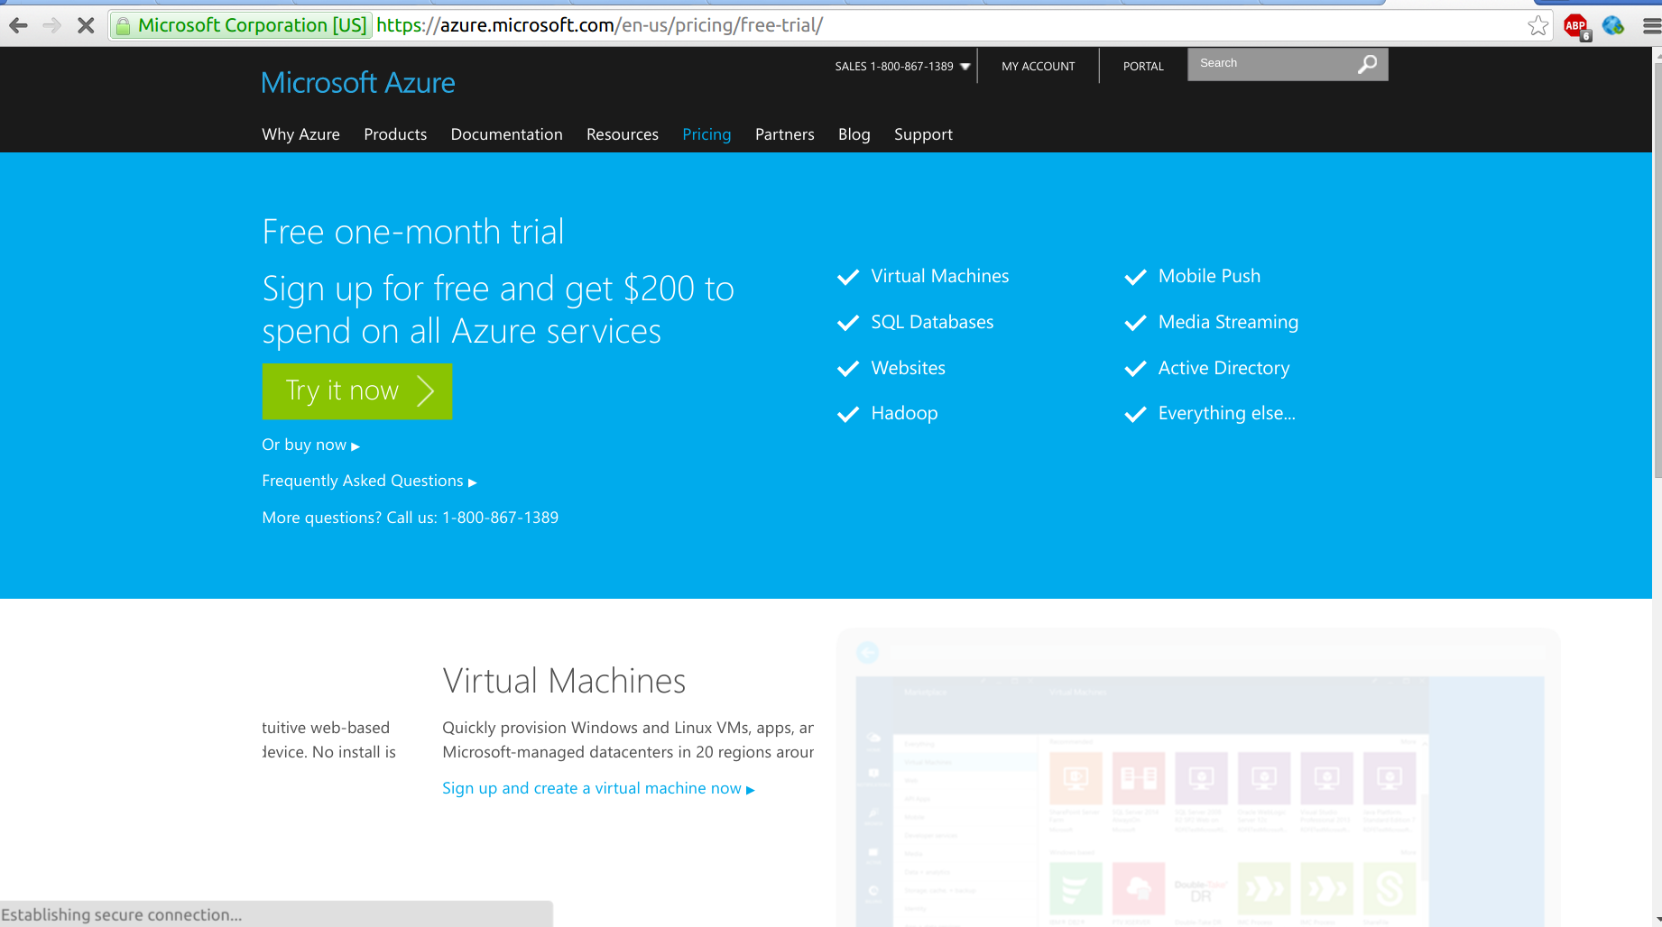

**Creating instance in Microsoft**

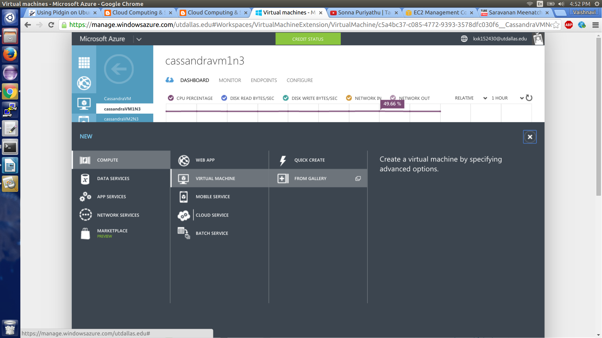

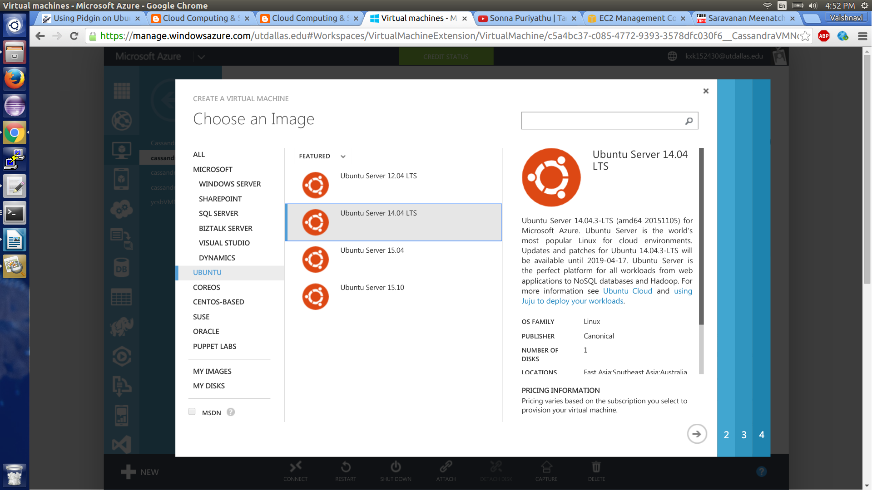

**Ubuntu instance 14.04 LTS**

**Select Standard A2 (2 cores, 3.5 GB) instance**

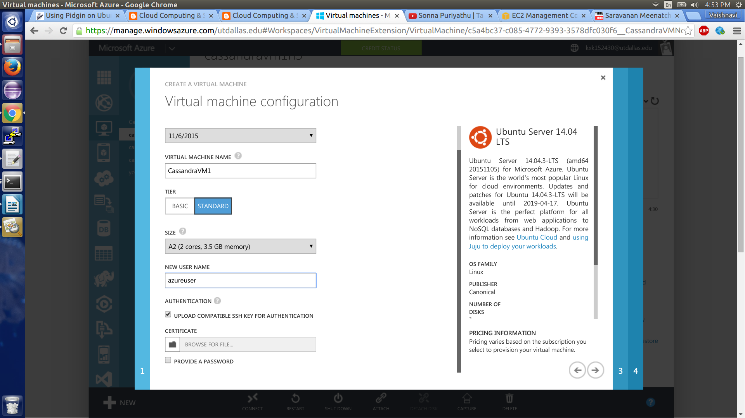

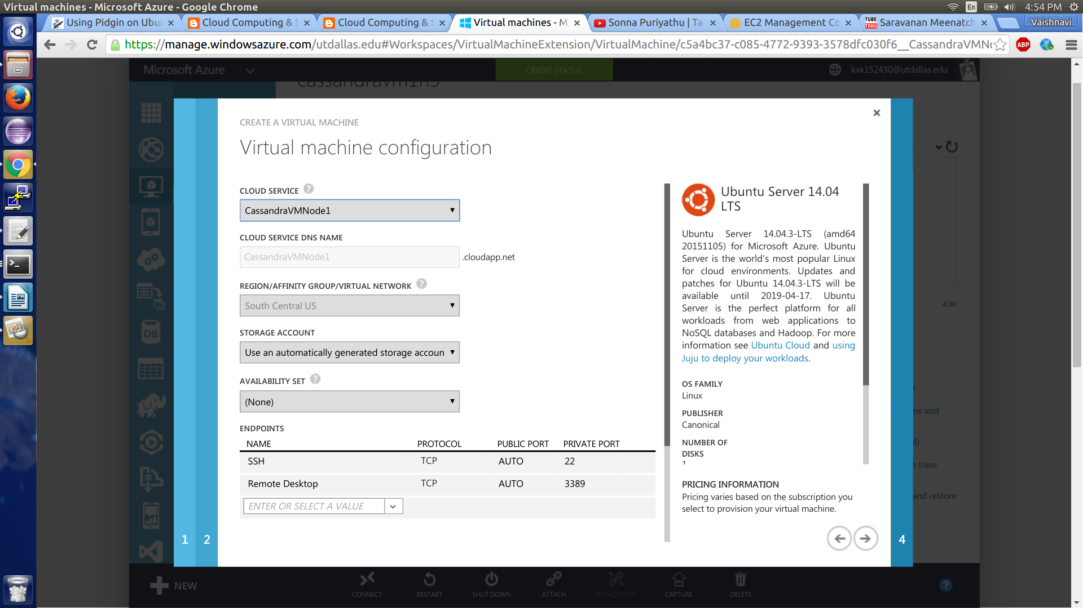

**Add instances in the same cloud service**

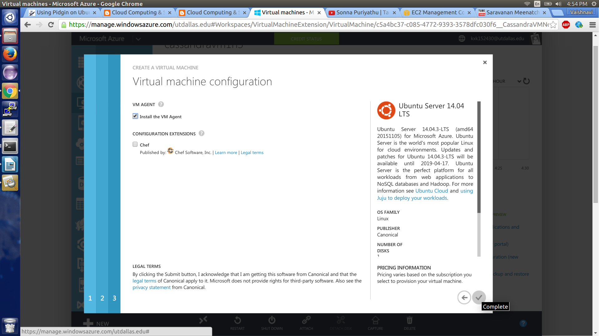

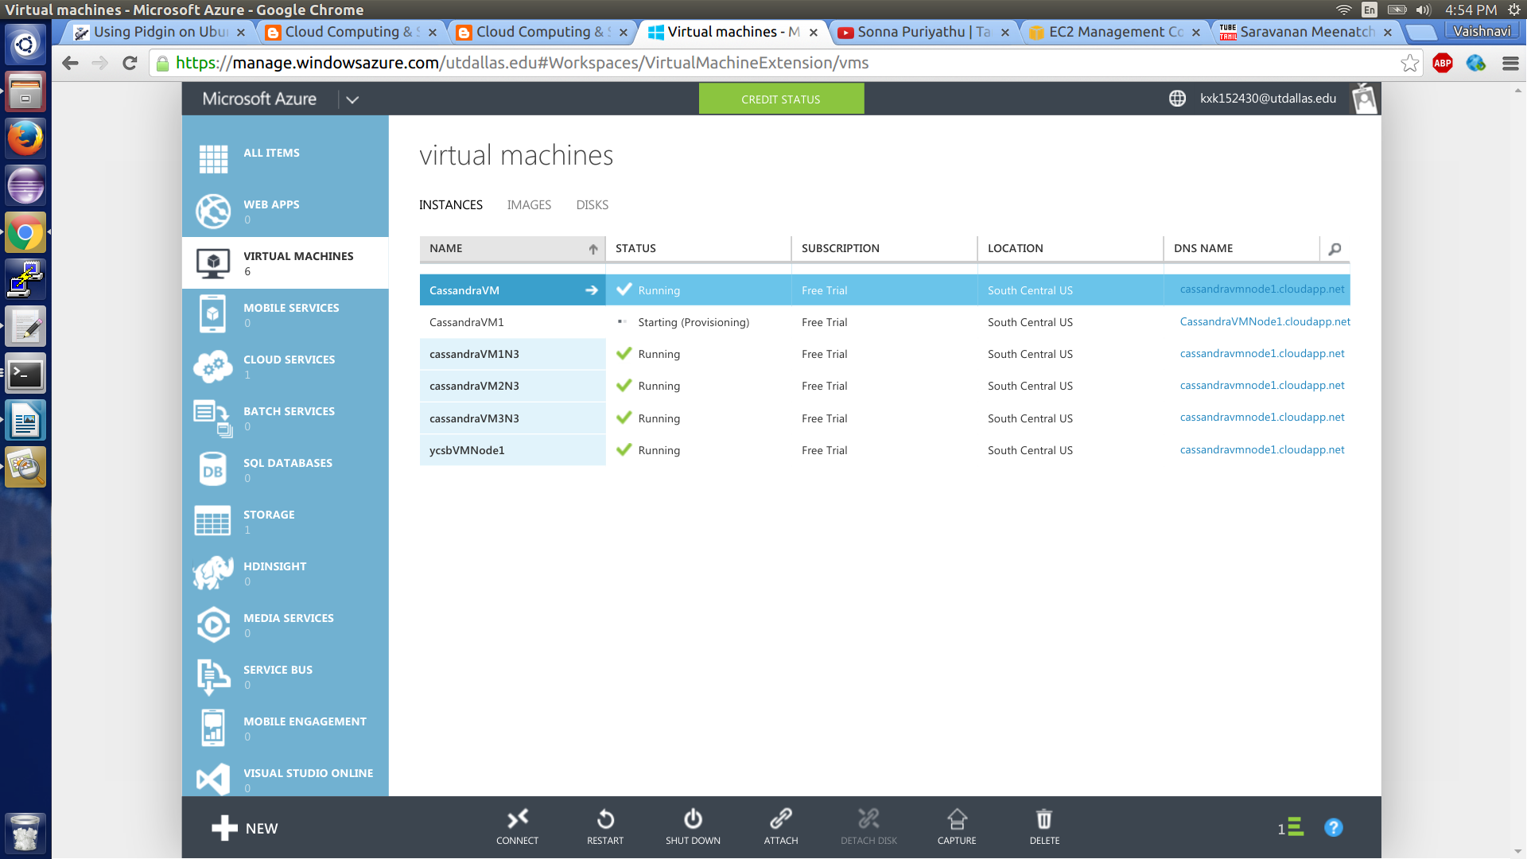

**Dashboard**

**IP address, Port number and DNS**

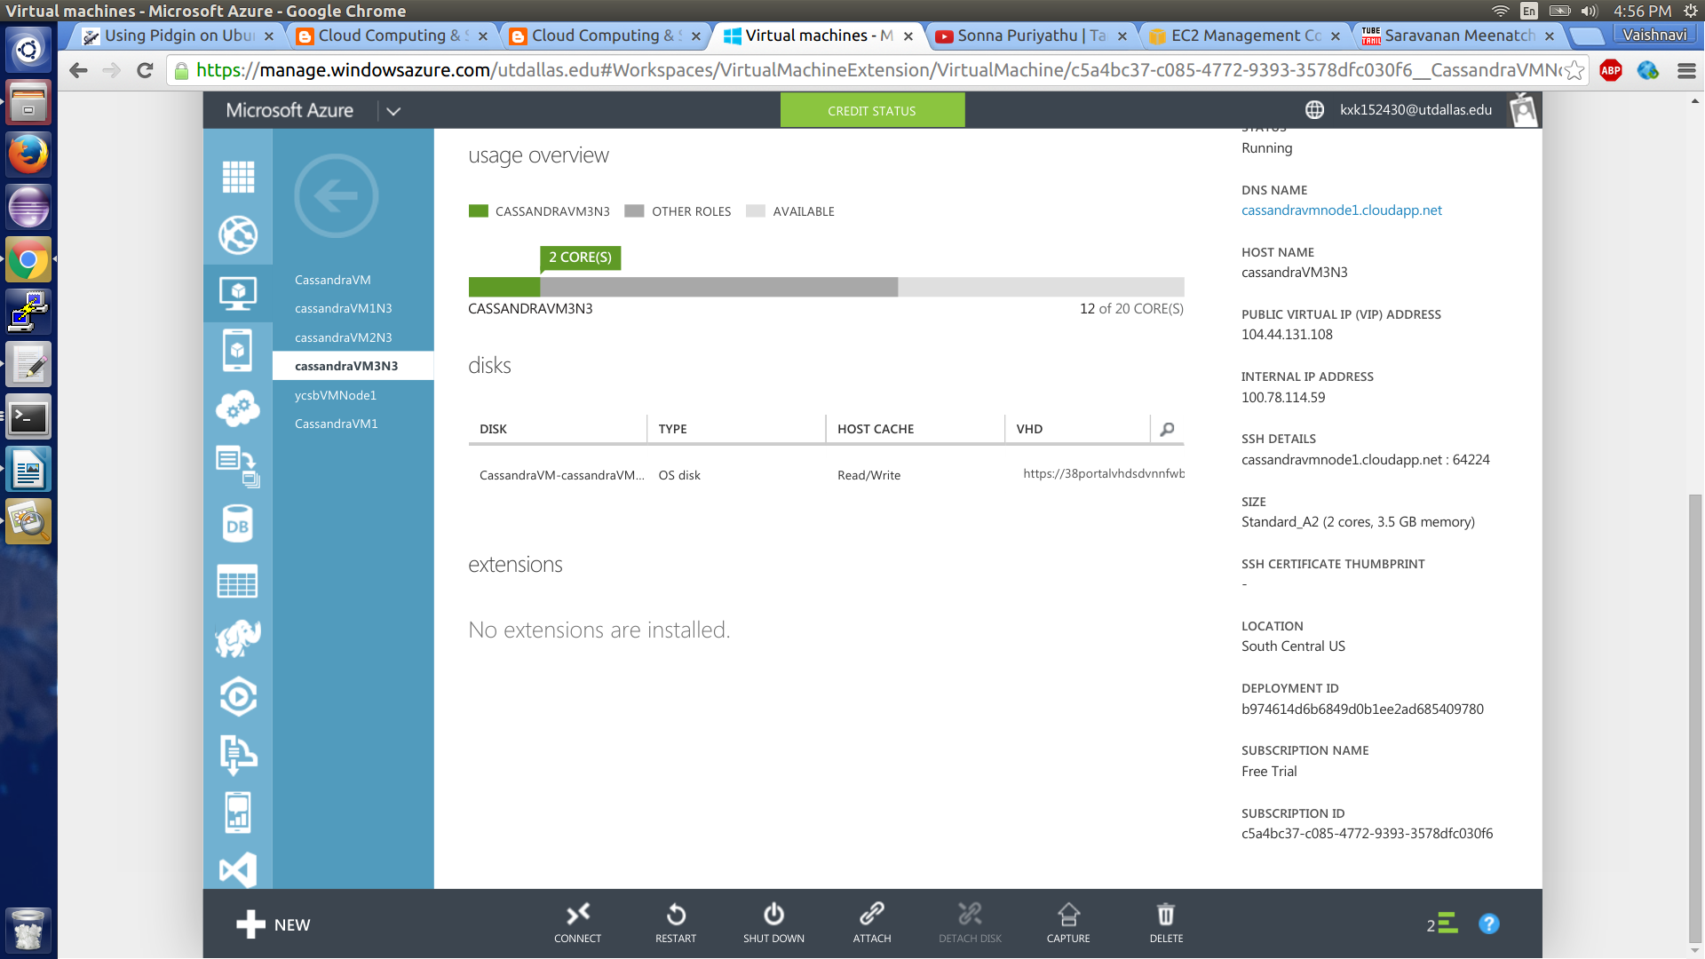

**Connect to VM**

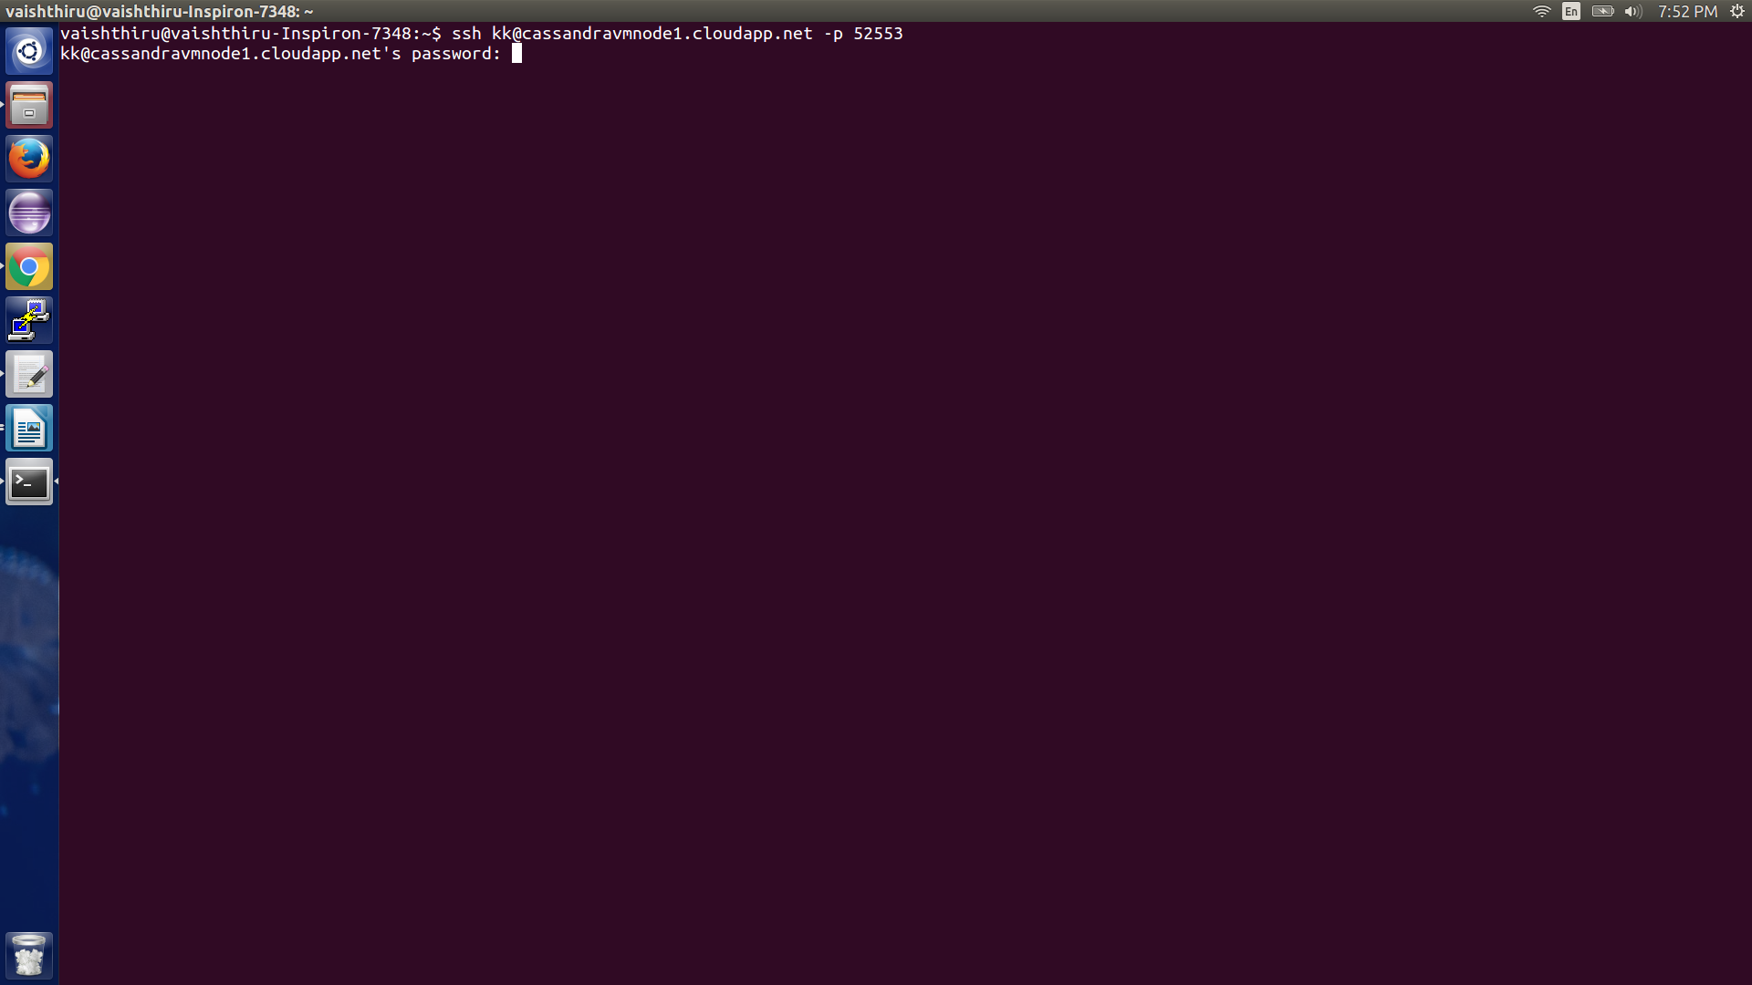

**Install Oracle Java 7 in Ubuntu PPA**

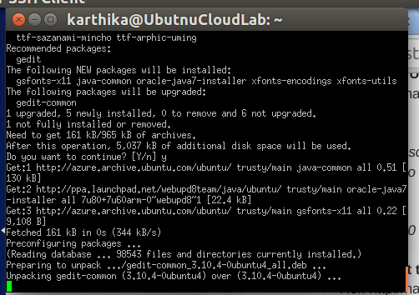

**Install Cassandra**

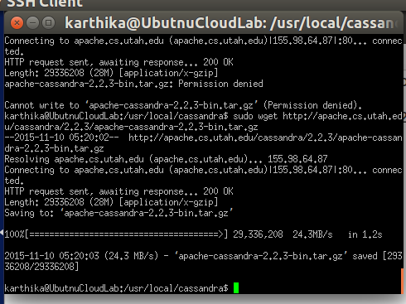

**Install YCSB**

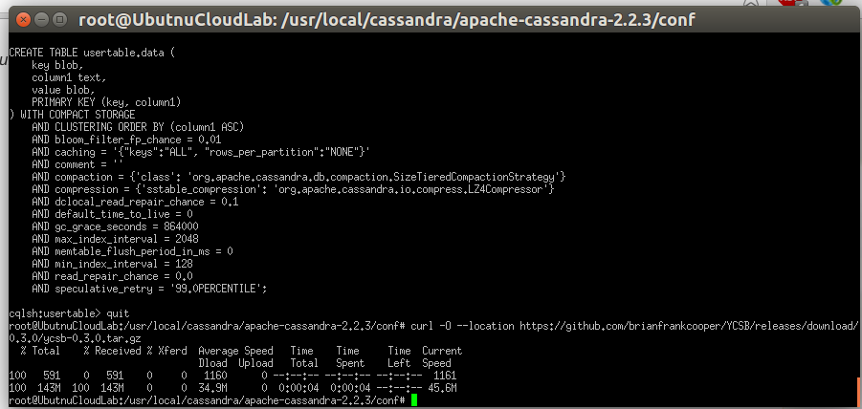

**Execute Cassandra**

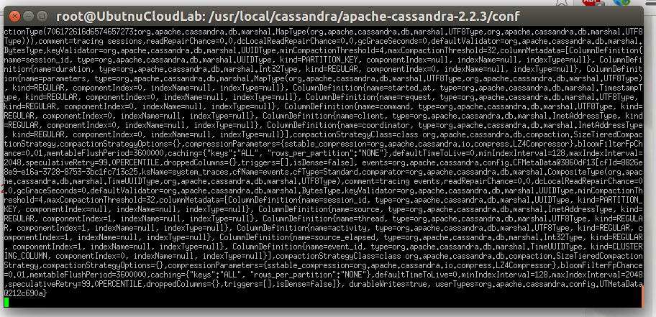

**After execution status and IP address**

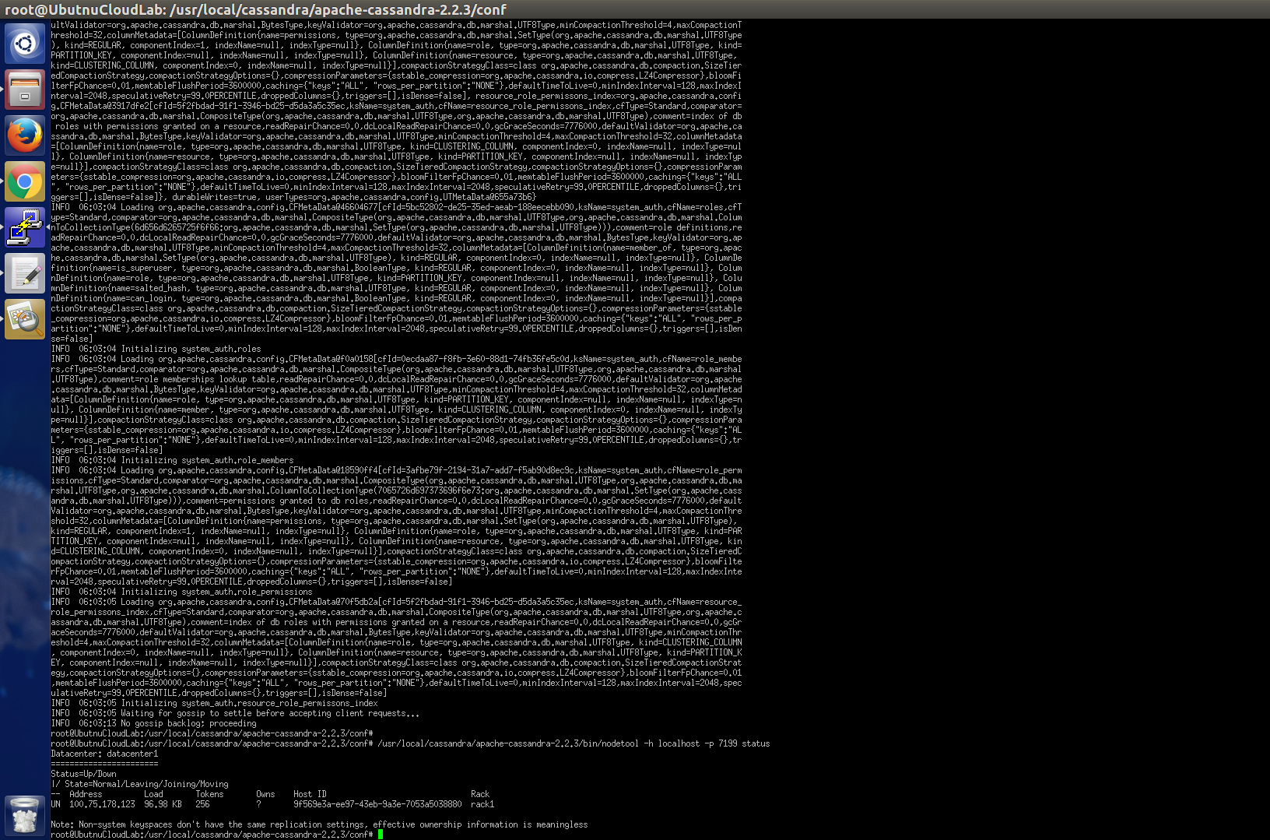

**Create key-space and table in Cassandra**

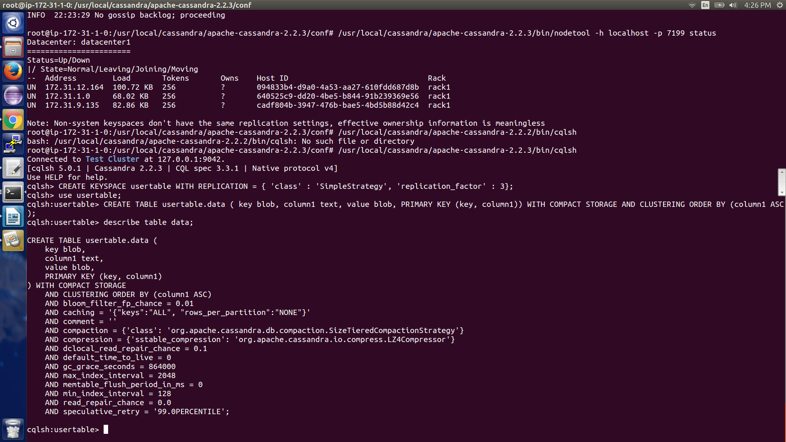

**Drop table for clean up before every load and run**

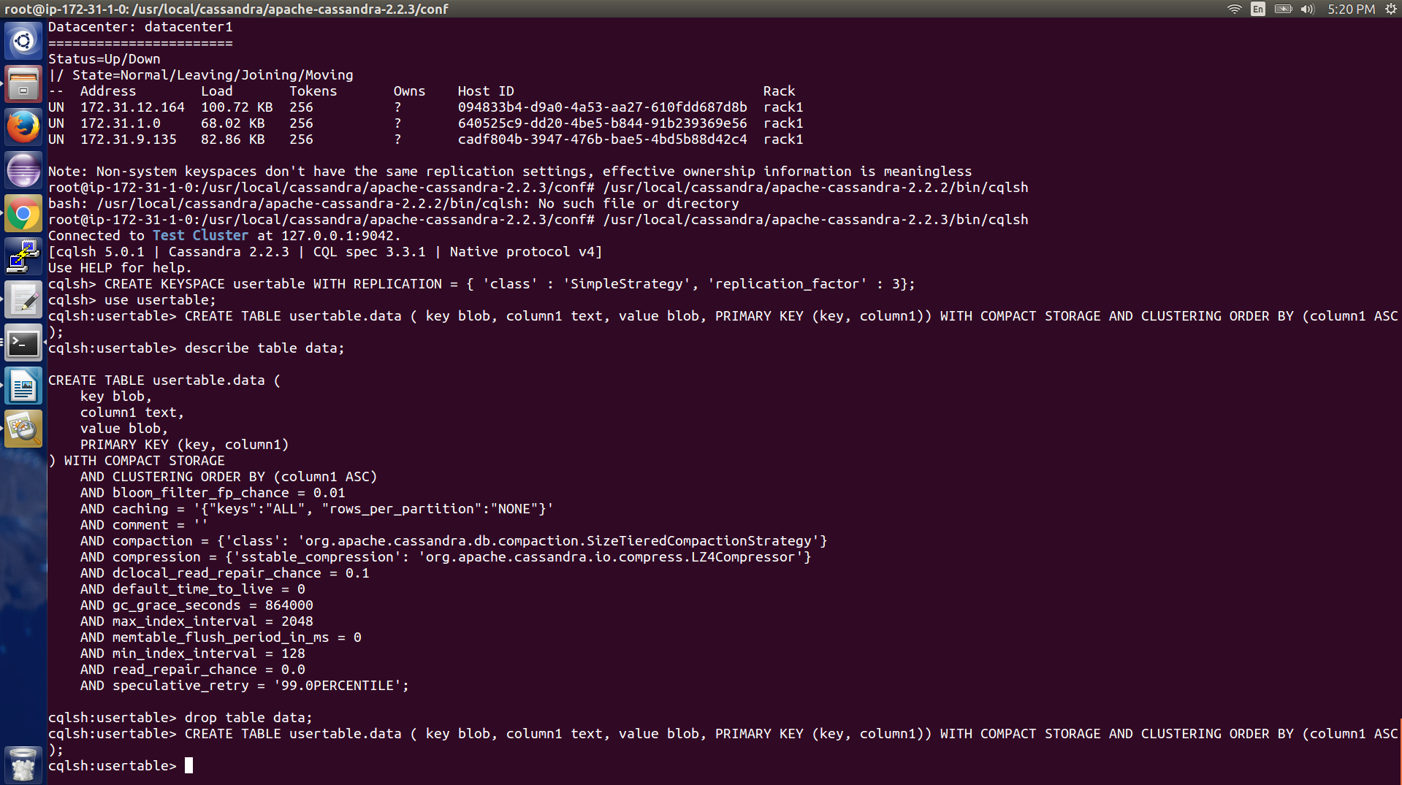

**Configuration of the instance and Price:**

**A2 – Standard Ubuntu Instances : 2 Cores, 3.5 GB, 135 GB**

**Price : $0.12/hr (or) $89/month**

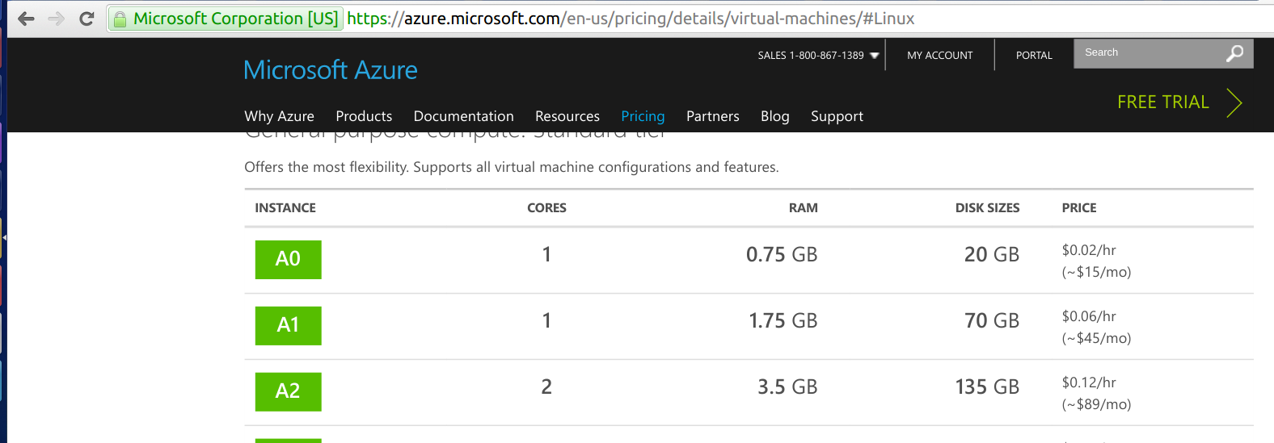

**AWS Pricing : $38.07/month**

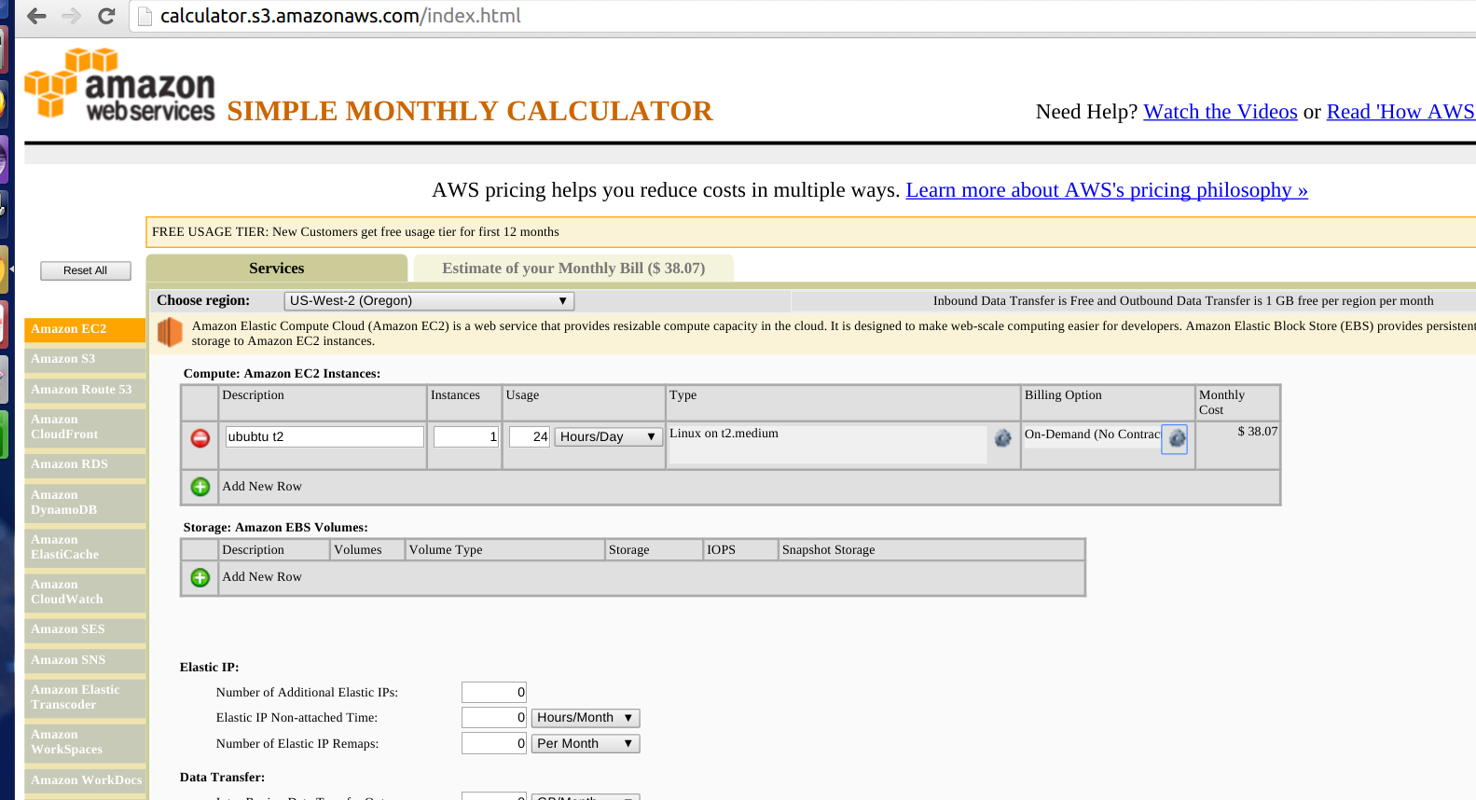

**Issues faced:**

* Ports were all same for different instances under same cloud. So error occurred during connection, Remote Desktop endpoint was added for creating different ports for each instance
* Created instances under different cloud services, hence it did not communicate , so create under same cloud service to recognize each other

**Benchmark result and load screen shots:**

**Node 1**

**Load 10:**

**Run 10:**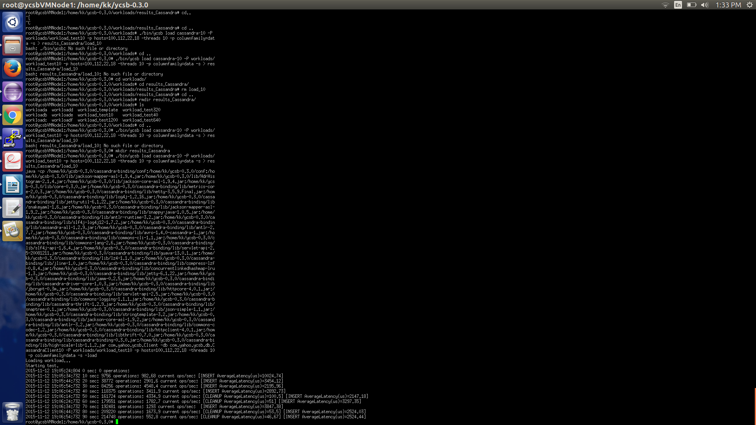

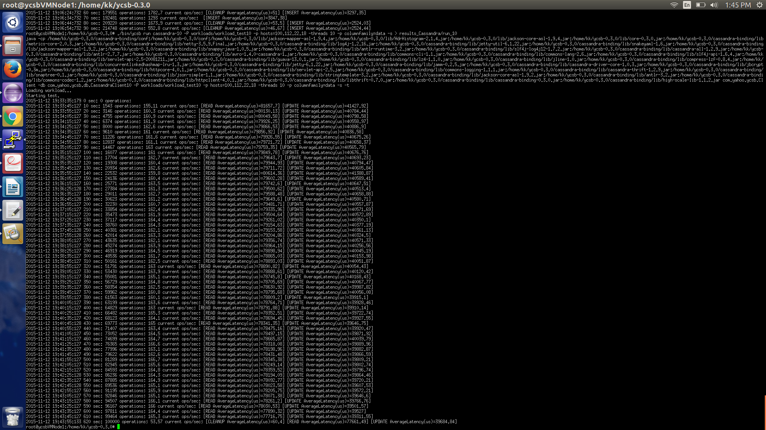

**Load 40:**

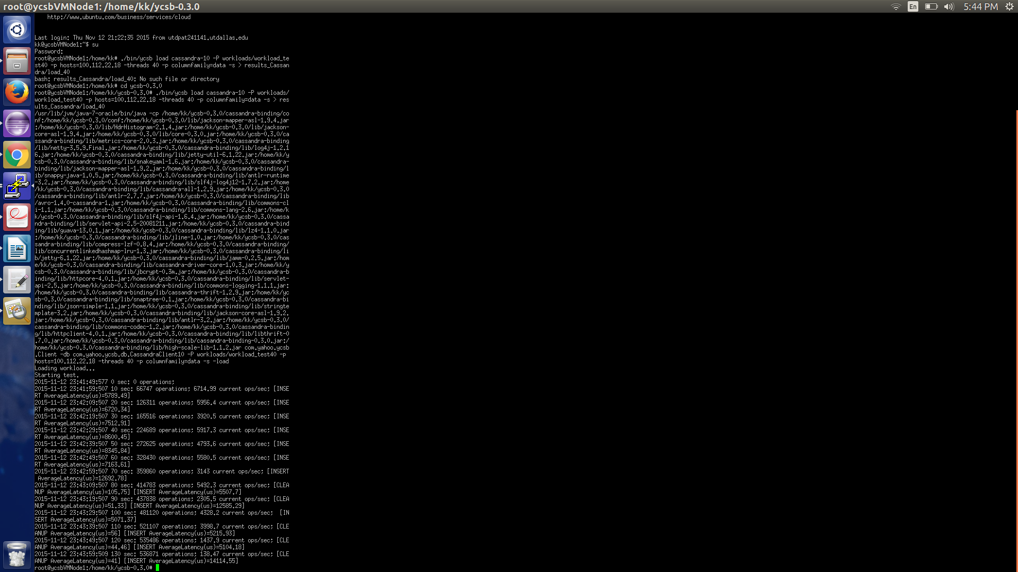

**Run 40:**

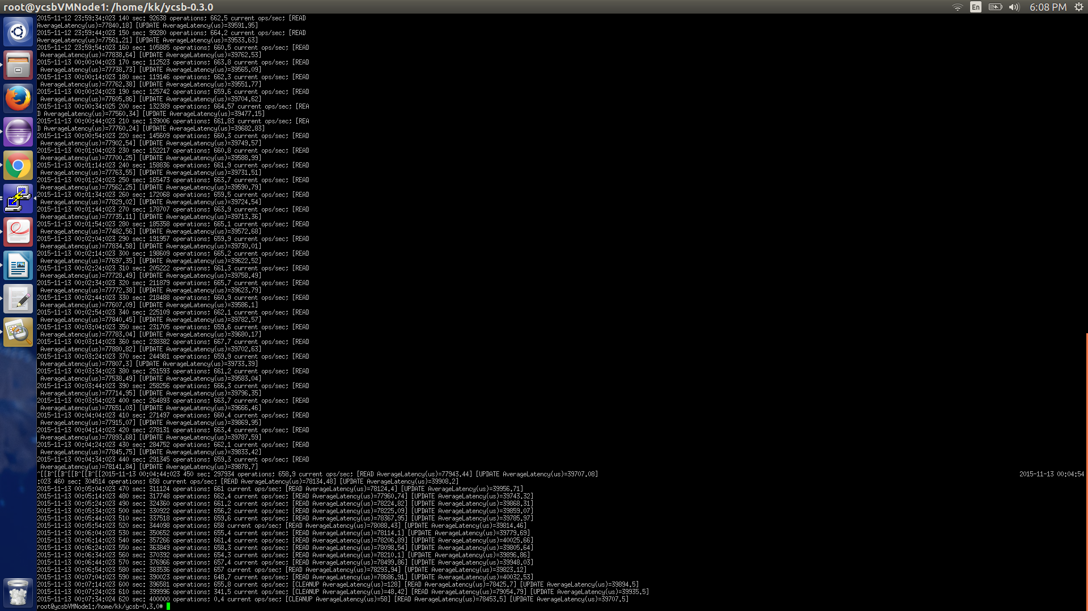

**Load 320:**

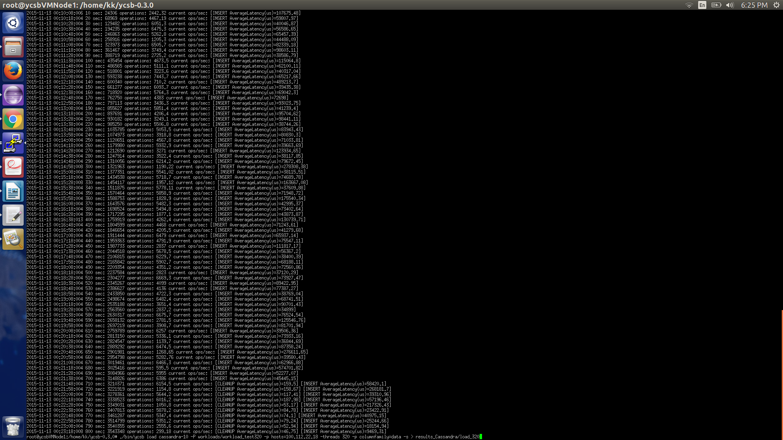

**Run 320:**

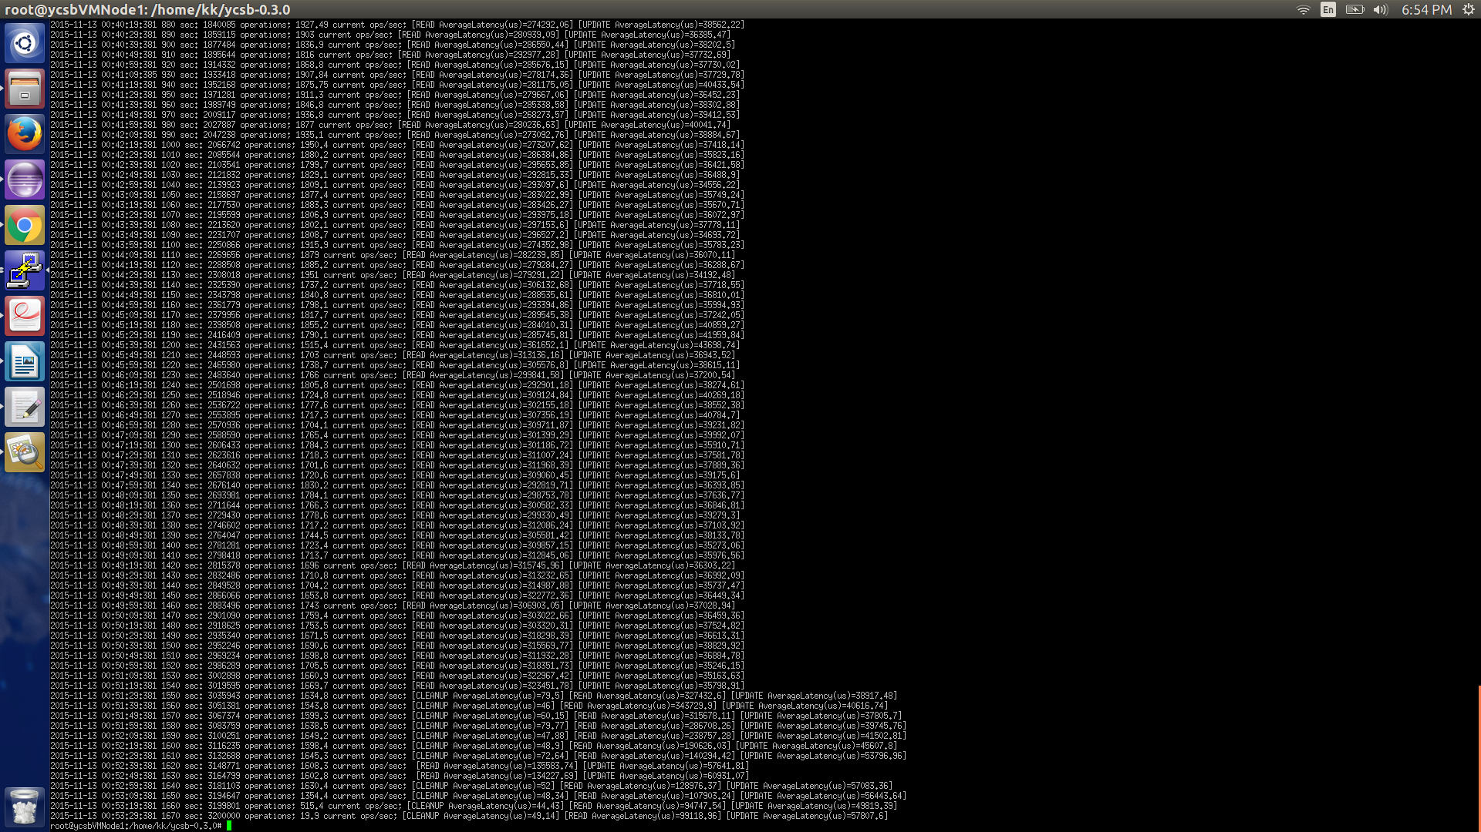

**Load 640:**

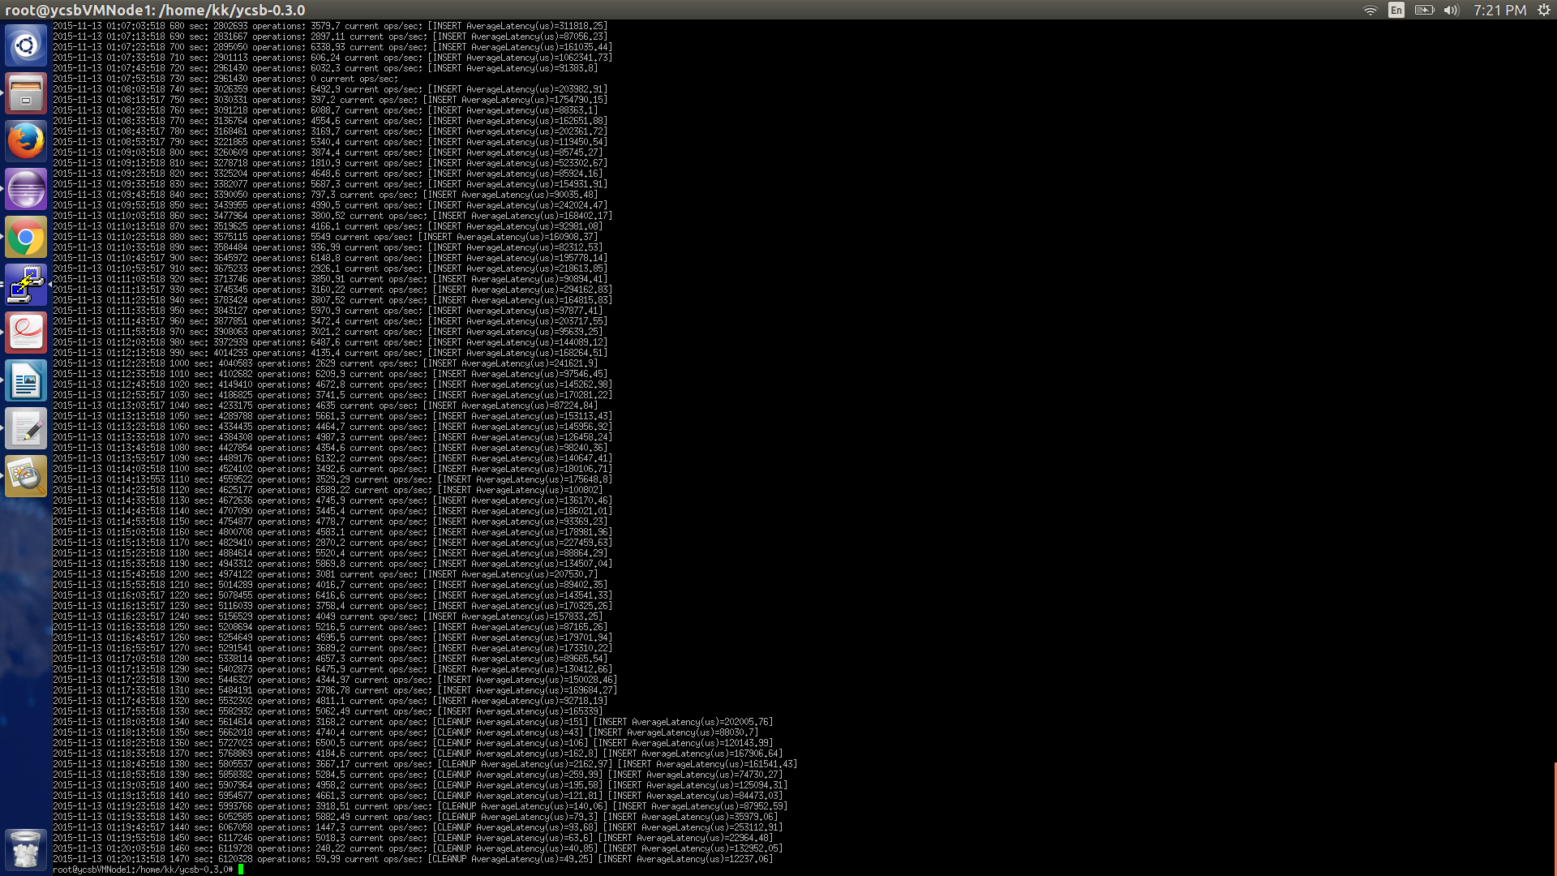

**Node 3**

**Load 10:**

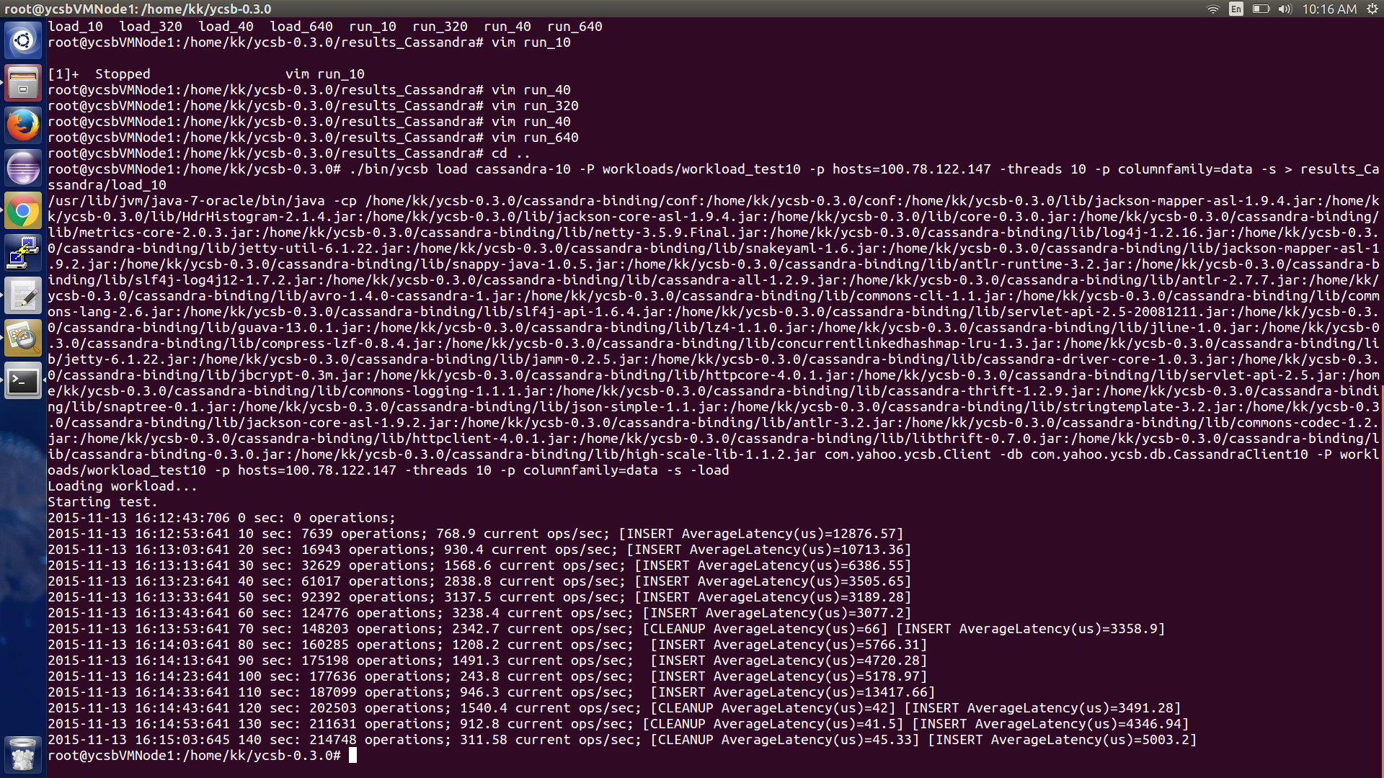

**Run 10:**

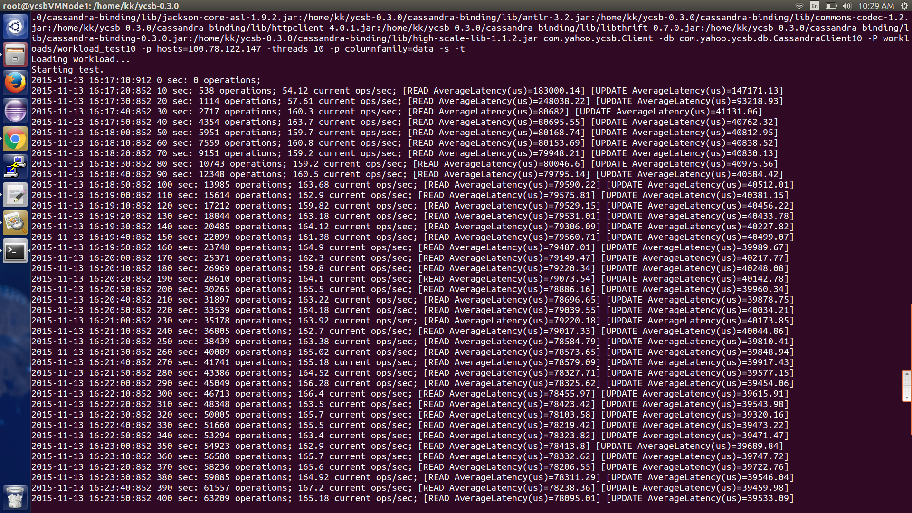

**Load 40:**

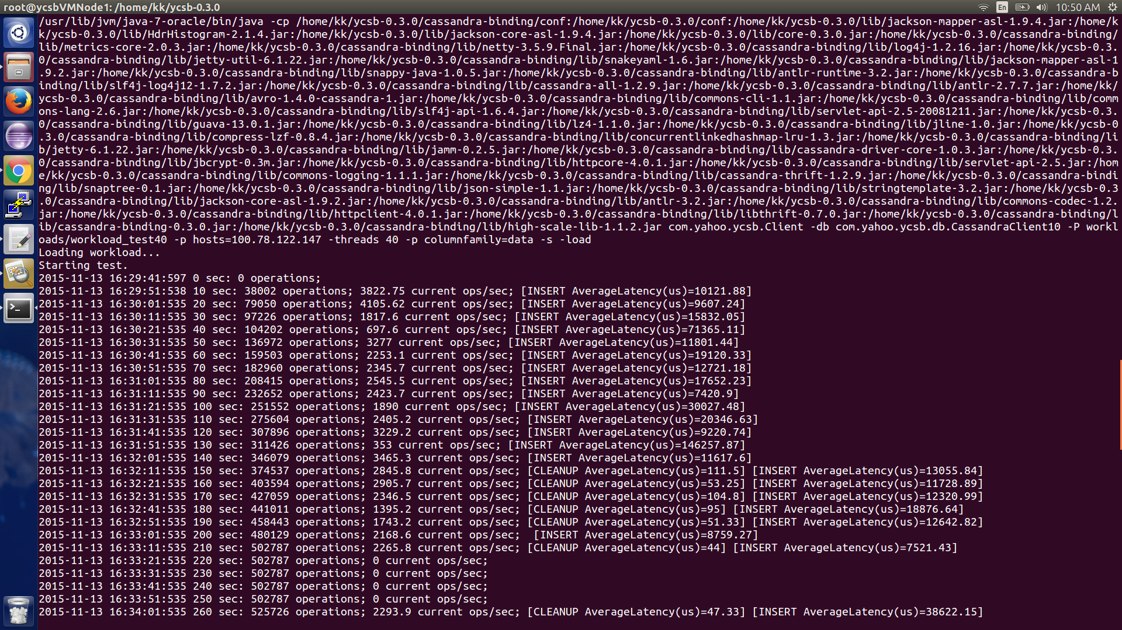

**Run 40:**

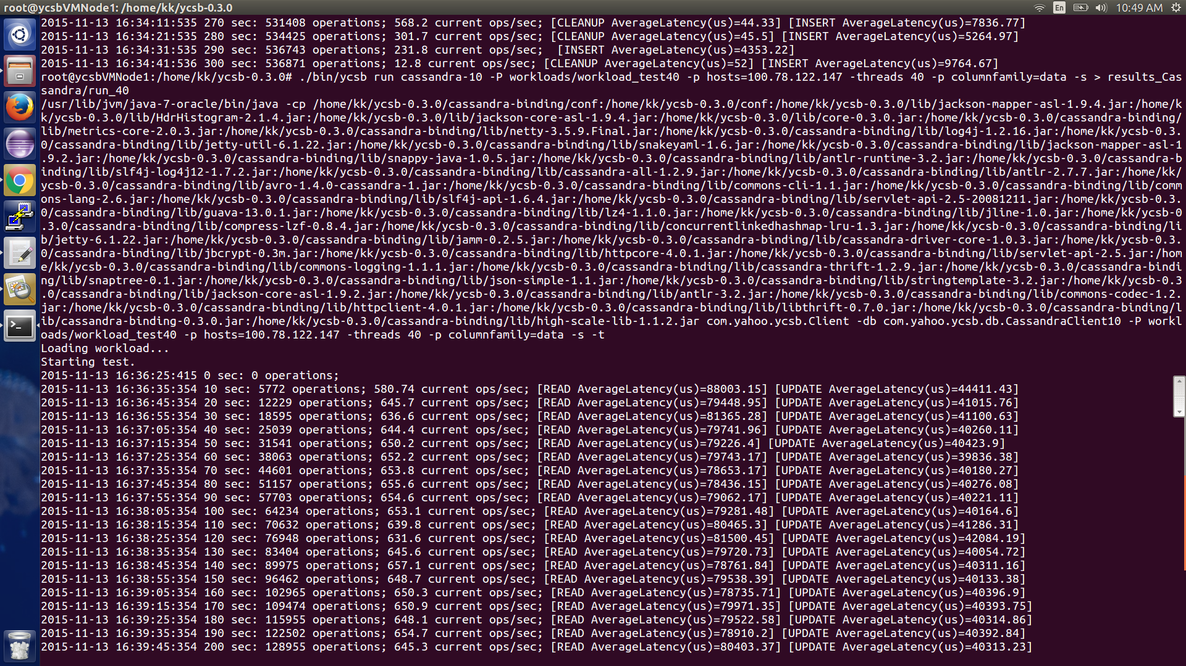

**Load 320:**

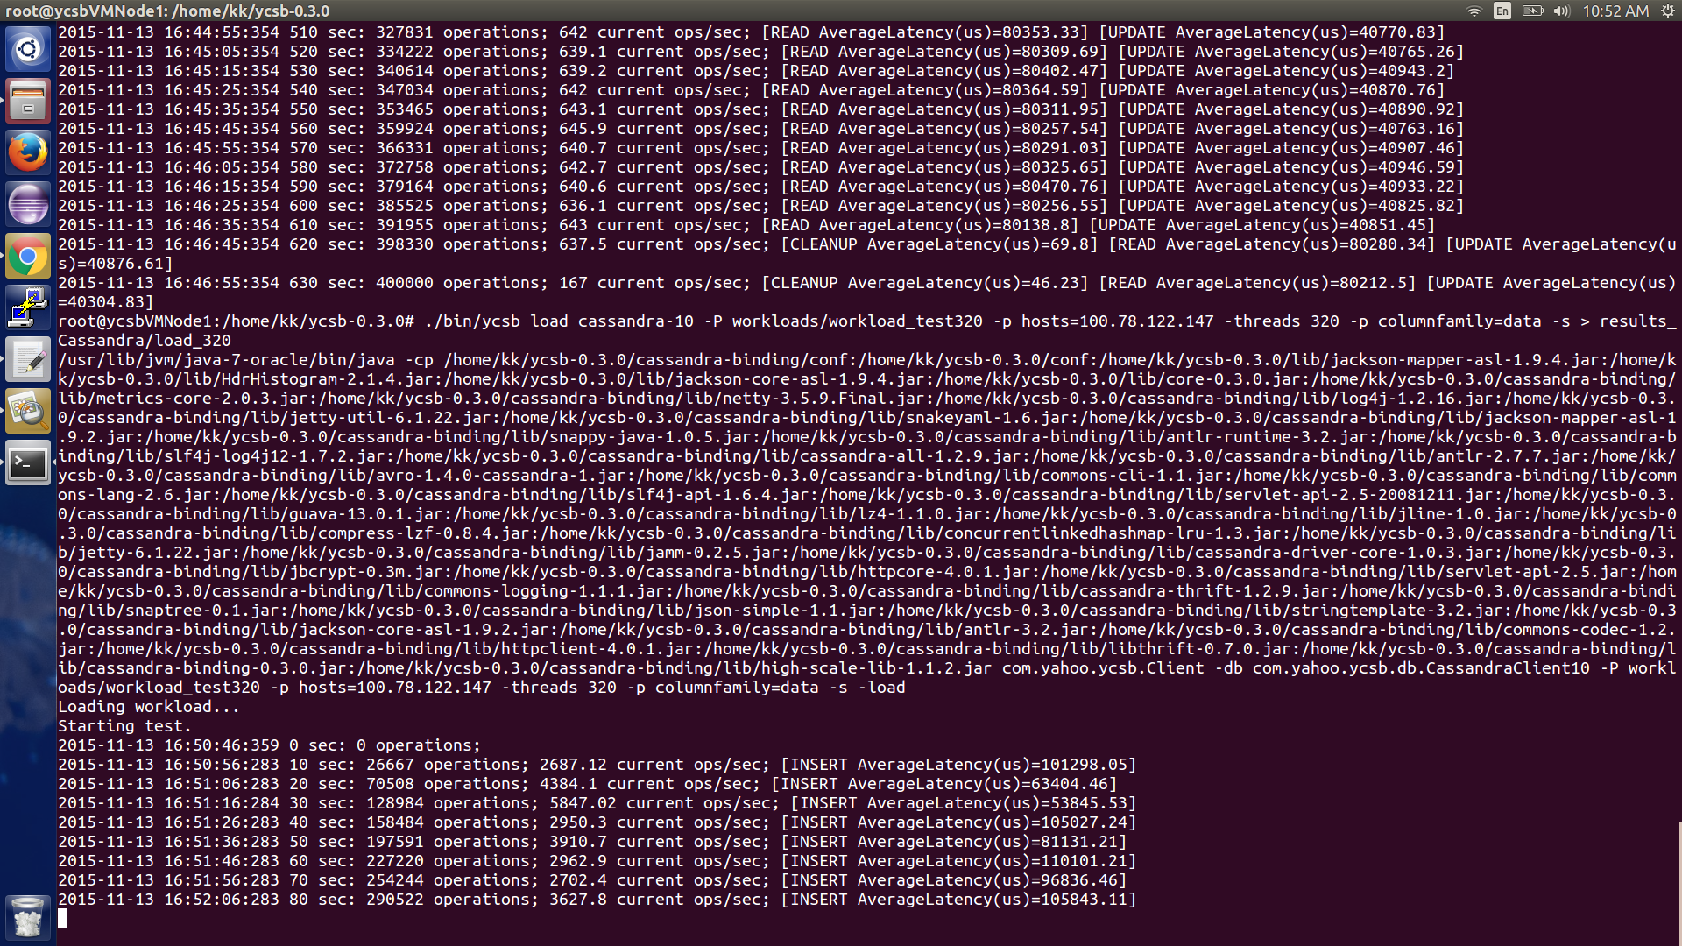

**Run 320:**

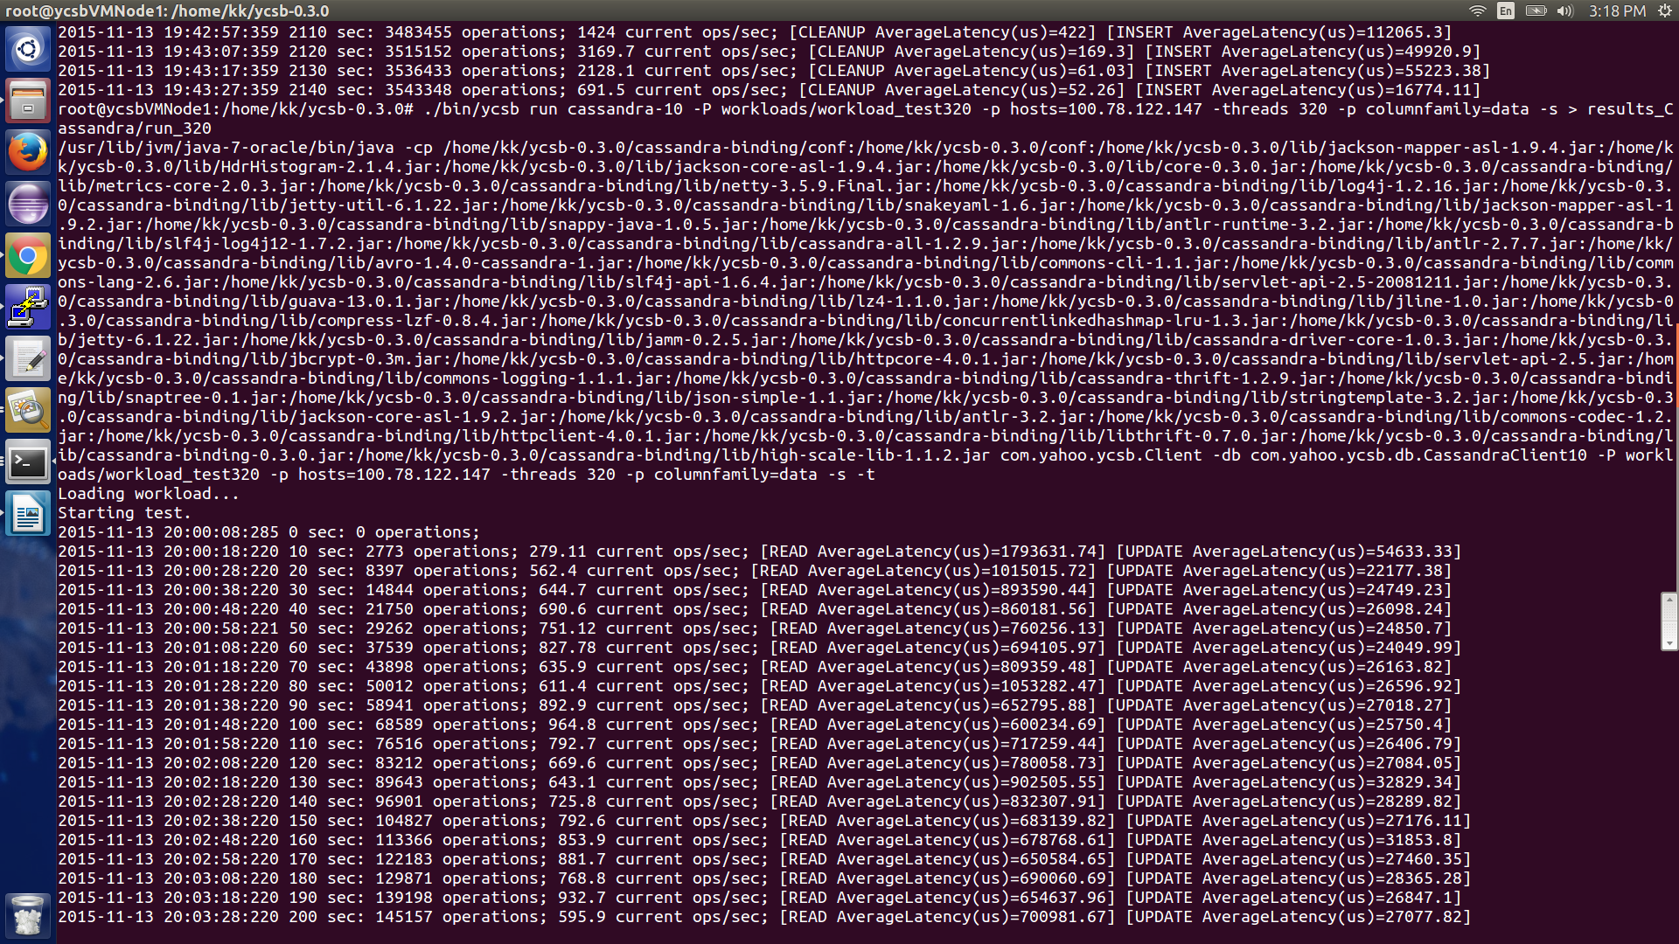

**Load 640:**

